Assessment tool 1
Name : Pooja s
Reg no. : 192524326
Course code and name : CSA0508 database management system
Slot : C
- UPS Product Tracking Information System
UPS prides itself on having up-to-date information on the processing and current location of each shipped item. To do this, UPS relies on a company-wide information system. Shipped items are the heart of the UPS product tracking information system. Shipped items can be characterized by item number (unique), weight, dimensions, insurance amount, destination, and final delivery date. Shipped items are received into the UPS system at a single retail center. Retail centers are characterized by their type, uniqueID, and address. Shipped items make their way to their destination via one or more standard UPS transportation events (i.e., flights, truck deliveries). These transportation events are characterized by a unique scheduleNumber, a type (e.g, flight, truck), and a deliveryRoute. Create an Entity Relationship diagram that captures this information about the UPS system.
Here's the ER diagram for the UPS tracking system, with the design decisions explained below.
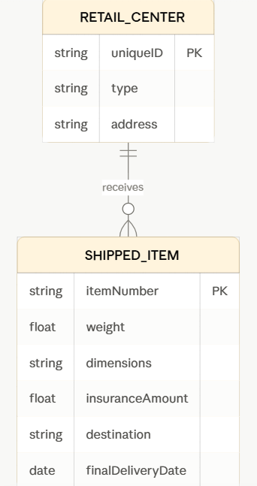
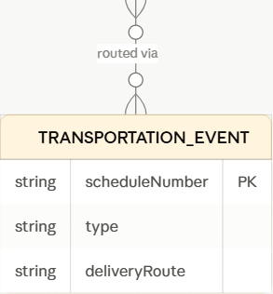
Entities and their attributes:
- Retail center — uniqueID (PK), type, address
- Shipped item — itemNumber (PK), weight, dimensions, insurance amount, destination, final delivery date
- Transportation event — scheduleNumber (PK), type, delivery route
Relationships:
- Retail center → Shipped item (receives): one-to-many. Each item is received into the system at exactly one retail center, but a retail center receives many items over time.
- Shipped item → Transportation event (routed via): many-to-many. The problem states an item makes its way to its destination via one or more transportation events, so an item can be linked to multiple events. Likewise, a single flight or truck delivery carries many items at once. This is the trickiest relationship in the model — a plain 1:N wouldn't capture the "multi-hop journey" aspect.
A couple of modeling notes worth considering as refinements:
- If you need to know the order in which an item passed through its transportation events (e.g., truck to airport, then flight, then truck to final address), you'd want to add an attribute like sequenceNumber on the many-to-many relationship itself, since plain M:N doesn't preserve ordering.
- destination is currently just an attribute of the item. If UPS needs structured address data (street, city, zip) for routing/sorting logic, that could become its own entity — but per the problem statement as given, treating it as a simple attribute is sufficient.

- Course Management System
Consider a university database for the scheduling of classrooms for final exams. This database could be modeled as the single entity set exam, with attributes course-name, section-number, room-number, and time. Alternatively, one or more additional entity sets could be defined, along with relationship sets to replace some of the attributes of the exam entity set,
as
• course with attributes name, department, and c- number
• section with attributes s-number and enrollment, and dependent as a weak entity set on course
• room with attributes r-number, capacity, and building Show an E-R diagram illustrating the use of all three additional entity sets listed.
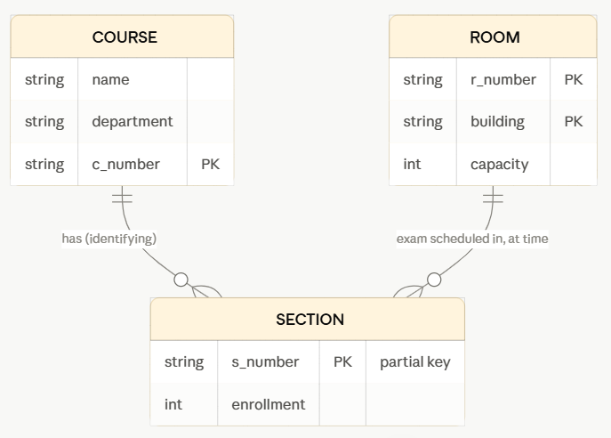
A few modeling points worth calling out, since the rendered diagram can't show every ER convention:
Course is a strong entity. c-number (or department + c-number together) serves as its primary key.
Section is a weak entity — it has no independent existence or unique key of its own; it only makes sense in the context of a course (e.g., "section 2" only means something once you know it's section 2 of CS 101). In standard Chen notation this gets a double-bordered rectangle, and the identifying relationship (here, "has") gets a double-bordered diamond. Mermaid's ERD syntax doesn't render that double-border convention, so in the diagram I've noted s-number as a partial key (dashed underline in Chen notation) rather than a full primary key — the true primary key of section is the composite (c-number, s-number).
Room is a strong entity, with its primary key being the composite (building, r-number), since room numbers repeat across buildings.
Exam is no longer an entity at all — it's now a relationship set between room and section, carrying the one surviving attribute, time. This is the core trick the exercise is testing: what used to be one flat entity (exam) with four attributes becomes three entities plus a relationship, and time ends up living on the relationship rather than on any entity, because a time only makes sense in the context of "this section's exam in this room."
Cardinalities:
- Course to section is one-to-many: one course has many sections, each section belongs to exactly one course (total participation — a section can't exist without its course).
- Room to section (the exam relationship) is one-to-many: a room can host many exams (at different times), but each section has exactly one exam, in exactly one room, at exactly one time.

- University Registrar’s Office Management System A university registrar’s office maintains data about the following entities:
(a) courses, including number, title, credits,syllabus, and prerequisites;
(b) course offerings, including course number, year, semester, section number, instructor(s), timings, and classroom;
(c) students, including student-id, name, and program;
(d) instructors, including identification number, name, department, and title.
(e) Further, the enrollment of students in courses and grades awarded to students in each course they are enrolled for must be appropriately modeled.
Construct an E-R diagram for the registrar’s office.

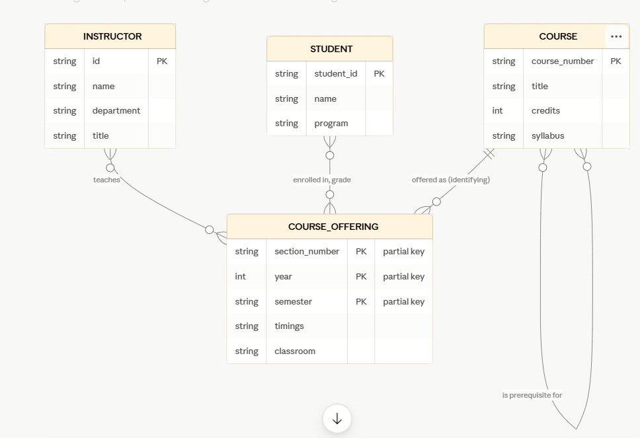
- Course — strong entity, course-number as PK, with title, credits, syllabus as attributes.
- Prerequisites — a recursive many-to-many relationship on course (a course can require several prerequisites, and be a prerequisite for several other courses), not an attribute.
- Course offering — a weak entity dependent on course, with partial key (section-number, year, semester) together, plus timings and classroom as attributes.
- Instructor(s) — many-to-many teaches relationship between instructor and course offering, allowing co-taught sections.
- Student — strong entity, student-id as PK.
- Enrollment/grades — many-to-many relationship between student and course offering, with grade as an attribute on that relationship, since a grade only makes sense per student-per-offering.
- Hospital Management System
Construct an E-R diagram for a hospital with a set of patients and a set of medical doctors. Associate with each patient a log of the various tests and examinations conducted. Construct appropriate tables for the above ER Diagram :
Patient(SS#, name, insurance)
Physician ( name, specialization)
Test-log( SS#, test-name, date, time)
Doctor-patient (physician-name, SS#)
Patient-history(SS#, test-name, date)
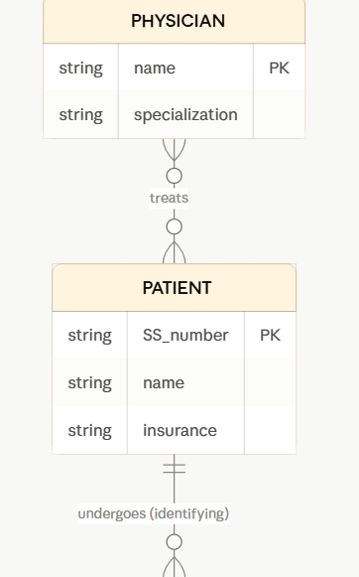
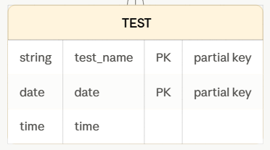
Entities → tables
- Patient (strong entity) → Patient(SS#, name, insurance) — a strong entity maps directly to a table using its own primary key.
- Physician (strong entity) → Physician(name, specialization) — here name is treated as the key, per the schema given (in a real system you'd normally want a proper physician ID, but I've kept it consistent with the tables you specified).
- Test (weak entity, dependent on Patient) → this is the entity behind both Test-log and Patient-history. A weak entity's table always includes the owning entity's primary key as a foreign key alongside its own partial key. Test has partial key (test-name, date) and the attribute time, so:
  - Test-log(SS#, test-name, date, time) is the full weak-entity table (owner key + partial key + descriptive attribute).
  - Patient-history(SS#, test-name, date) is essentially the same weak entity's key columns without time — worth noting this is a bit redundant with Test-log in strict normal-form terms (it's a subset of the same columns), so in practice you'd usually just query Test-log rather than maintain a separate table. I've kept both since your schema specifies them, but flagging it in case this was meant to represent something distinct (e.g. a summary/reporting view).
Relationships → tables
- Treats (many-to-many between Physician and Patient) → Doctor-patient(physician-name, SS#) — a standard M:N relationship becomes its own table holding the keys of both participating entities.
- Undergoes (the identifying relationship between Patient and Test) doesn't get its own separate table — because Test is a weak entity, this relationship is absorbed into the Test table itself (that's why Test-log already carries SS#, the patient's key, as a foreign key rather than needing a fourth junction table).
- Company Project Management System
Construct an ER Diagram for Company having following details :
Company organized into DEPARTMENT. Each department has unique name and a particular employee who manages the department. Start date for the manager is recorded. Department may have several locations.
• A department controls a number of PROJECT. Projects have a unique name, number and a single location.
• Company’s EMPLOYEE name, ssno, address, salary, sex and birth date are recorded. An employee is assigned to one department, but may work for several projects (not necessarily controlled by dept). Number of hours/week an employee works on each project is recorded; The immediate supervisor for the employee.
• Employee’s DEPENDENT are tracked for health insurance purposes (dependentname, birthdate,
relationship to employee).
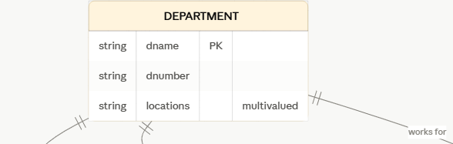
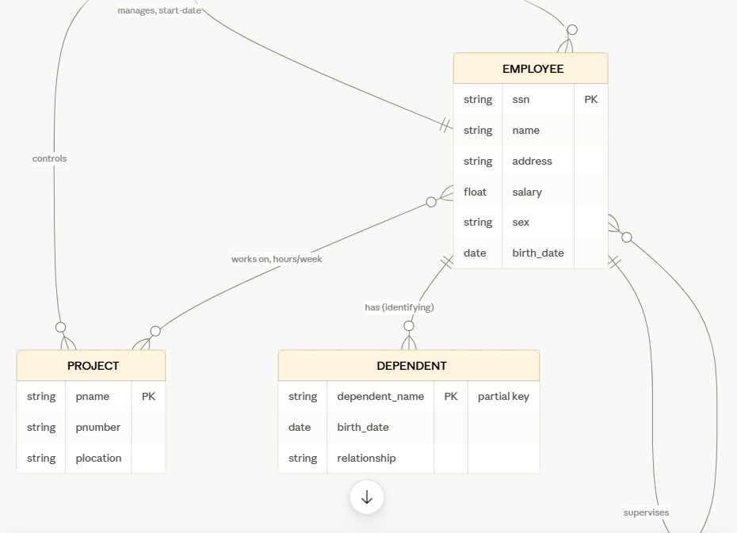
Same request as before — regenerating the diagram in case it didn't come through:Recap of the key design choices:
- Department — dname is the primary key (stated as unique); locations is multivalued, since a department can have several.
- Two separate department–employee relationships: manages (strict 1:1, carries start-date) and works for (1:N — every employee belongs to exactly one department). These are distinct relationships, not one — the manager is also, separately, a regular employee of some department.
- Project — pname is the key, with a single plocation (unlike department, only one location).
- Controls — 1:N from department to project.
- Works on — M:N between employee and project, carrying hours/week, kept separate from "works for" since the prompt specifies an employee can work on projects their own department doesn't control.
- Supervises — a recursive 1:N relationship on employee (one supervisor, many supervisees).
- Dependent — a weak entity owned by employee, with dependent-name as its partial key.

- Explain schema and instance with examples. Distinguish between logical schema, physical schema, and view schema.
Schema vs instance:
- Schema = the database's structure/design (tables, columns, types, constraints) — defined once, rarely changes.
- Instance = the actual data stored at a given moment — changes constantly.
Example: Student(roll_no, name, dept, cgpa) is the schema. The rows currently in that table right now are the instance.
Three schema levels:
- Physical schema — how data is stored (files, indexes, disk layout).
- Logical schema — what data exists and how it's related (tables, keys, relationships) for the whole database.
- View schema — what a specific user/application sees (a customized subset or reshaping of the logical schema).
Each layer hides the details of the one below it, so changes at one level (e.g., adding a disk index) don't force changes at the others.
- Identify the entities, attributes, and relationships for a Bank Management System and construct its ER diagram.
Entities & key attributes:
- Customer — customer-id (PK), name, address, phone
- Account — account-number (PK), balance, type
- Loan — loan-number (PK), amount
- Branch — branch-name (PK), city, assets
- Employee — employee-id (PK), name, telephone, salary
Relationships:
- Depositor: Customer M:N Account (attribute: access-date)
- Borrower: Customer M:N Loan
- Maintains: Branch 1:N Account
- Offers: Branch 1:N Loan
- Employs: Branch 1:N Employee
- Banker for: Employee 1:N Customer
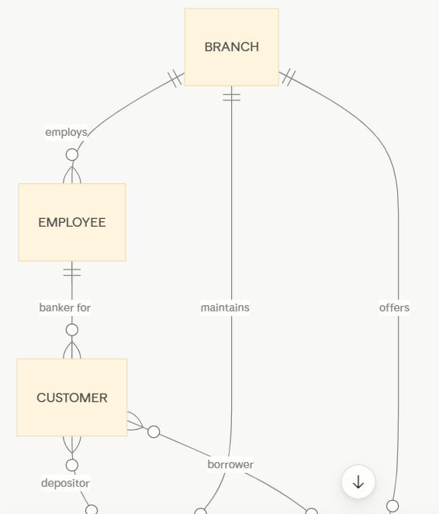
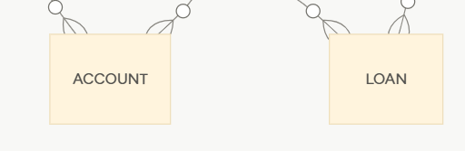

- Explain the Extended ER (EER) model. Describe the concepts of generalization, specialization, and aggregation.
Employee ssn, name, salary ISA disjoint, partial Secretary typing-speed Engineer engineer-type Manager bonus
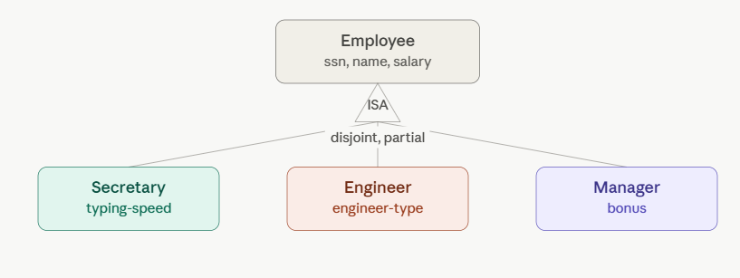
Extended ER (EER) model adds three constructs to basic ER to handle inheritance and complex relationships:
- Generalization (bottom-up) — combine similar entities into a shared superclass. E.g., Car and Truck → generalized into Vehicle.
- Specialization (top-down) — split one entity into subclasses with extra attributes. E.g., Employee → Secretary, Engineer, Manager.
  - Can be disjoint (no overlap) or overlapping, and total (every instance must belong to a subclass) or partial.
- Aggregation — treats a whole relationship as a single entity so it can participate in another relationship. E.g., Employee–works-on–Project treated as one unit, so Manager can "manage" that combination.
- Design an EER diagram for a Hospital Management System incorporating inheritance and weak entities.
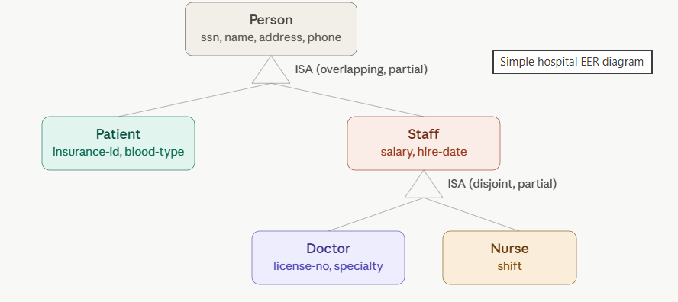

- Explain the role of a DBA (Database Administrator) and the responsibilities associated with the position.
A DBA (Database Administrator) manages and maintains a database system on an organization's behalf. Key responsibilities:
- Schema definition — designs the logical schema (tables, relationships, constraints).
- Storage & access method definition — decides physical storage structure and indexing for performance.
- Schema modification — updates the schema as needs change, while preserving data independence.
- Authorization — grants/controls user access permissions to data.
- Routine maintenance — backup & recovery, monitoring disk space, and performance tuning.

